1. **Agenda:**
   1. How to evaluate some pre-conditions before executing scenarios.
2. **Examples**:
   1. When using Selenium, maybe you want to delete some cookies before opening the browser from the Selenium.
   2. Before testing API, maybe you want to check if connection is made properly with server using some API key.   
      If it is working, then you can do GET, POST to the API.
3. 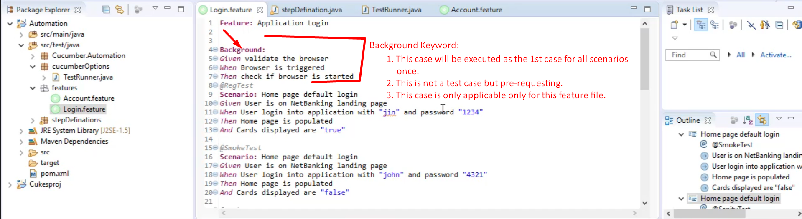
4. **Another Requirement**:
   1. You want to define a specific pre-request (Background) for each scenario in one feature file.   
      Let’s see in next lectures.